**Ten-Year Urban Forestry Action Plan**

**Project Evaluation**

**October 1, 2015**

This evaluation was conducted in September of 2015 by the project facilitation team, led by the Institute for Environmental Negotiation (IEN) and Dialogue + Design, to assess the development of the Ten-Year Urban Forestry Action Plan planning process. The consultants provided the project leadership and direction, supported by the Project and Advisory Teams (see below) who provided expertise on different areas as research and funding needs. The team reviewed trends and factors that will influence UCF in the next 10 years, as well as strengths, opportunities, issues and challenges. It also reviewed the current status of UCF programs, activities, resources, and scientific research. The project team synthesized all of those inputs and identified specific needs and gaps that were used to develop the goals, strategies and actions for the next ten years. In addition, community outreach was done through face-to-face and a digital engagement process to enrich the Action Plan. The following figure shows how the community was engaged through the whole process.

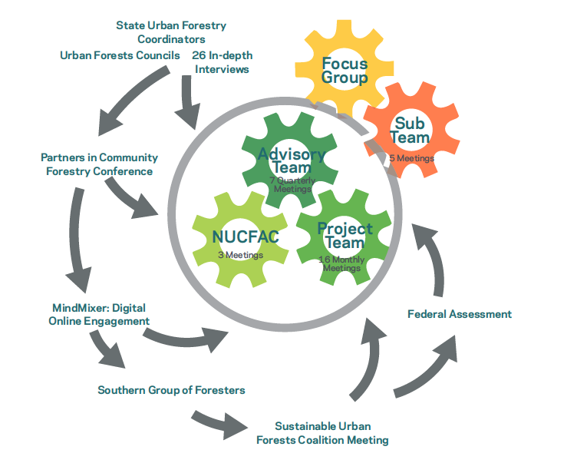

This evaluation includes a quantitative as well as a qualitative analysis. The quantitative analysis shows different metrics related to community outreach, literature research, and the results from the project evaluation online survey. The qualitative analysis includes the summary of the project evaluation discussion held with the Project Team and Strategic Advisory Team as well as final reflections from the facilitation team.

Project Team:

* Kathy McGlauflin, American Forests Foundation, project oversight and contract management, expertise in Urban and Community Forestry education programs
* Tanya Denckla Cobb, University of Virginia Institute for Environmental Negotiation, project direction and lead, facilitation and community engagement
* Christine Muehlman Gyovai, Dialogue + Design Associates, senior project management, facilitation and community engagement
* Tatiana Marquez, IEN Project Manager
* Abigail Sandberg, University of Virginia Institute for Environmental Negotiation, document and graphic design
* IEN staff, Eiline Cai, Elise Cruz, Katie Gronsky, Jason Knickmeyer, Elizabeth Moore, Ross Weaver, and Shujing Zhang
* Nancy Stremple, USDA Forest Service: project guidance, NUCFAC executive staff
* Kathleen Wolf, Ph.D., University of Washington, expertise in socio-ecological research
* Jennifer Cotting, University of Maryland Environmental Finance Center, finance and costing
* Eric Reed, University of Maryland Environmental Finance Center, finance and costing
* Mark White, Ph.D., University of Virginia McIntire School of Economics, economic finance and costing

Advisory Team:

* Federal Interests: Ed Macie, Forest Service Urban Forestry Coordinator
* State Interests: Nick Kuhn, Missouri State Urban Forestry Coordinator
* Municipal Interests: Angel Spell, City of Spokane
* Broad Community of Practice Interests, and NUCFAC liaison: Greg Ina, Davey Resources Group, and Liam Kavanagh, City Parks Alliance.
* Professional Association and Nonprofit Interests: Jennifer Judd Hinrichs, Convener: Sustainable Urban Forests Coalition
* Grassroots Community-Level Interests: Carrie Gallagher, Director, Alliance for Community Trees (first half of the project), Sarah Anderson, Program Director, Alliance for Community Trees (second half of project)
* Scientific Community Interests: Lynne Westphal, Research Social Scientist, Northern Research Station, USDA Forest Service and Beth Larry, National Program Lead, Urban Research, USDA Forest Service
* Project Team: Kathy McGlauflin, Tanya Denckla Cobb, Christine Muehlman Gyovai, Nancy Stremple

**Section A: Quantitative Analysis**

* + 1. **In Depth Interviews:** During the summer of 2014, the facilitation team conducted 26 interviews of thought leaders from the urban forestry community. They were asked to share their perspective and insights about progress made in the last ten years, as well as to highlight specific progress in the realm of programs, activities, tools, and resources.

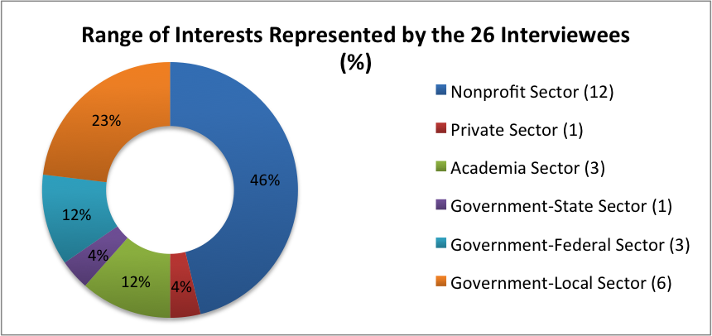

* + 1. **Community Outreach:** More that 1000 participants contributed to the Action Plan through various face-to-face and on-line community outreach efforts, which included:
* Federal/State Urban Forestry Coordinators – consultation via emails from USFS- (Summer-Fall 2015)
* Personal Interviews – 26 in-depth thought leader interview (Summer 2014)
* Scientist Interviews (Spring 2015)
* MindMixer online engagement – prioritization of 14 key issues, to identify priority Action Plan goals; prioritization of strategies; suggesting actions to implement the strategies (November-December 2014).
* Conferences (e.g., 2014 November - Partners in Community Forestry and  ACTrees National Meeting; January 2015 - Washington D.C. Sustainable Urban Forest Coalition, January 2015 - Mobile, Southern Group of State Foresters).
* Focus Group participants – to develop discuss and develop targets for implementing each Action Plan goal (April 2015)

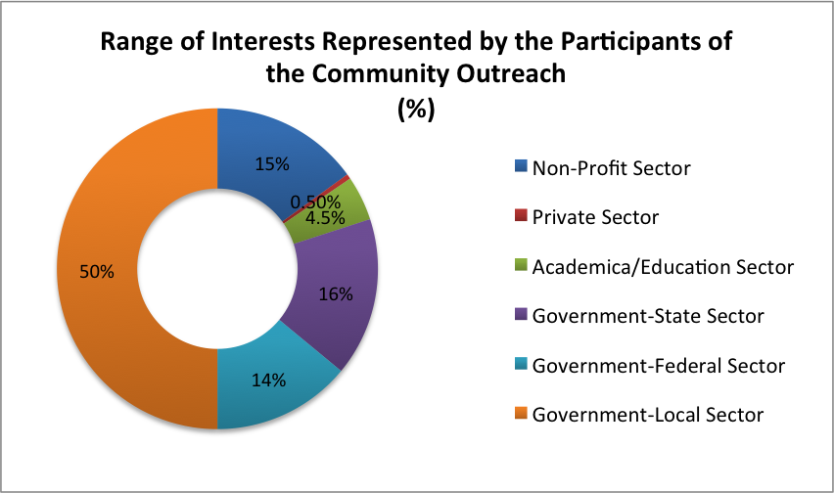

* + 1. **Urban Forestry Community Stakeholder Engagement:** A national stakeholder engagement using the MindMixer Platform, elicited urban forestry community feedback during November and December 2014. Participants prioritized the 14 Key Issues and developed ideas for implementation strategies. Nearly 3,000 unique individuals visited the site, about 550 people answered one or more questions, and there were more than 15,000 page views. The average age of participation was 47, and more than half of the participants have ten or more years of experience in the urban forestry field. While nearly every state had someone participating in the engagement, most participants were from coastal and metropolitan regions. Numerous comments were received by email and phone as well. Finally, hundreds of participants were engaged in person at the Partners in Community Forestry conference in November of 2014, at the Sustainable Urban Forests Coalition meeting in February 2015, at three NUCFAC meetings (two of which were in-person meetings; the facilitators joined one meeting by tele-conference), and the Southern Group of Foresters meeting.

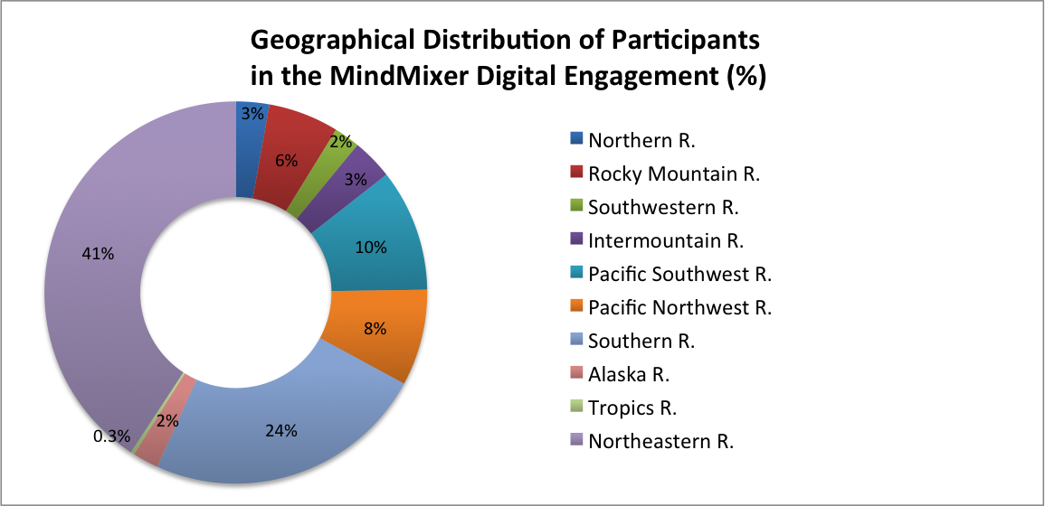

Note: Not all MindMixer participants answered the demographic question

* + 1. **Evaluation Survey:**

A Project Evaluation survey was designed with input from the Project Team. The Survey was sent out to all participants – the Project Team, Strategic Advisory Team, individual interviewees, all focus group participants, and all MindMixer participants. Of the 611 people who received this survey, 81 answered, representing a rate of 13.2 percent. Below you will find different graphics and the comments summarizing the responses for each of the eight evaluation questions.

**Note: The national average from email surveys is 24.8%, which suggests that these results may not be representative or statistically valid.**

***Question 1:***

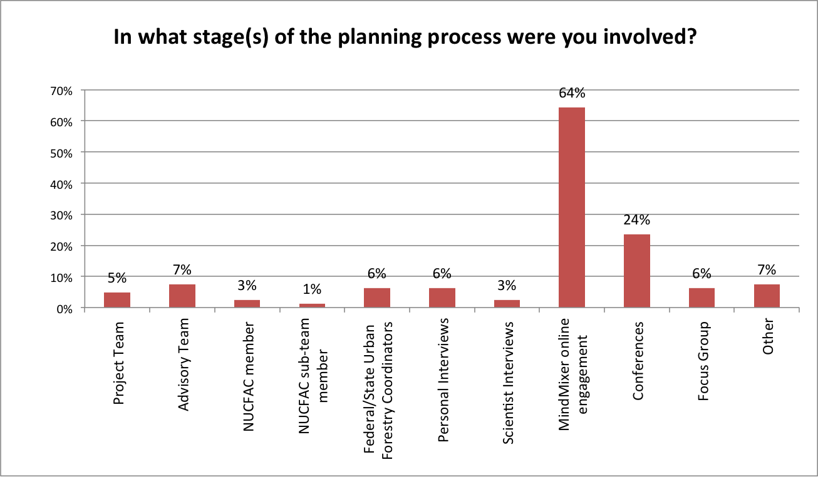

Individual Comments

* Responded to online tool
* Have not really been involved
* I provided input during the open review of the draft
* Web participation about what I thought was important for the ten-year plan
* E-mail requests for input
* This survey would have been relevant if it was given within four weeks of the original survey. Beyond that it is in no way a good measure of what individuals remember about their initial survey. Answers or experience. Good luck.

***Question 2: To what extent do you Agree or Disagree with the following statements:***

A). When you became engaged, the different engagement opportunities were clearly explained:

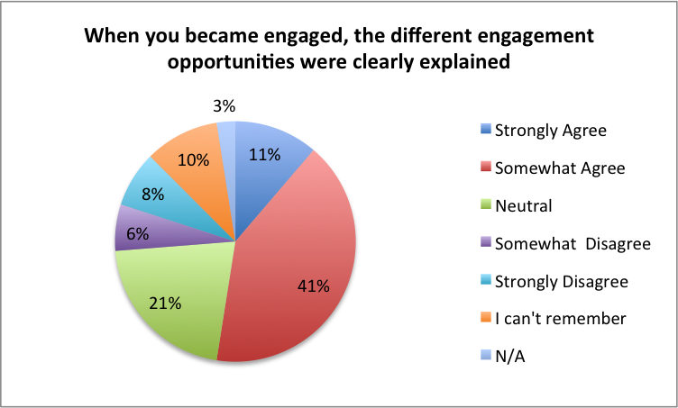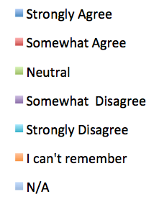

B) If you were a participant in the Project Team, Advisory Team, or NUCFAC, you were able to help shape the actual action planning process. (Note: 65% of participants participated in MindMixer)

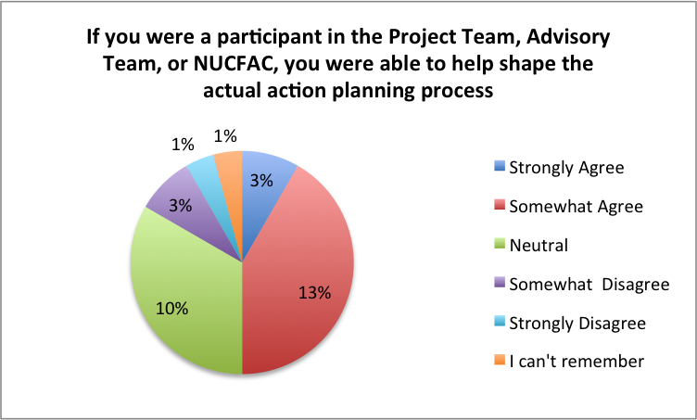

C) You participated in the planning process and had the opportunity to submit ideas for the Action Plan

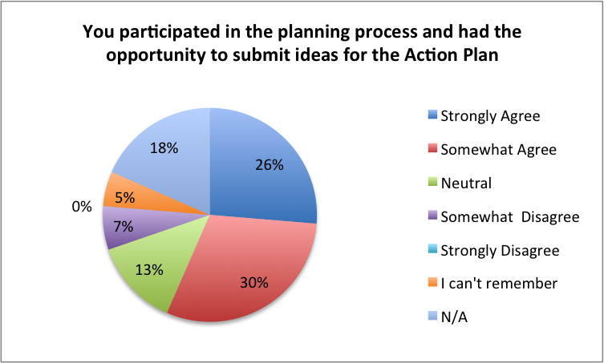

D) You were provided sufficient information to be able to provide meaningful input for the Ten-Year Action Plan

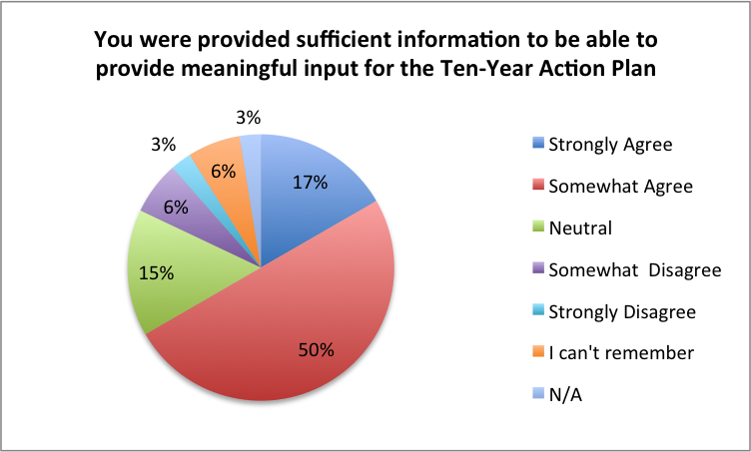

E) Your ideas were acknowledged verbally, in person, or electronically

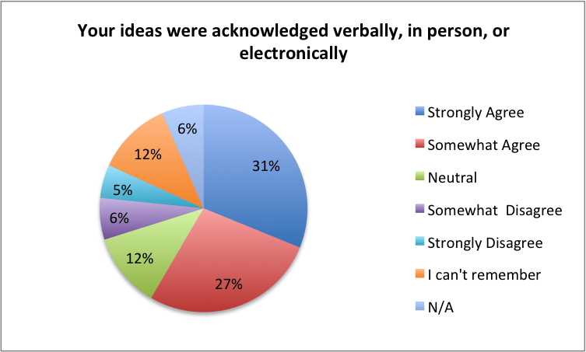

F) You would have liked to participate more and/or provide more input during the Action Planning Process

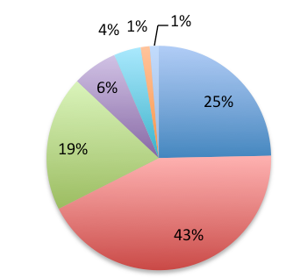

G) You would have liked to participate less and/or provide less input in the Action Planning Process

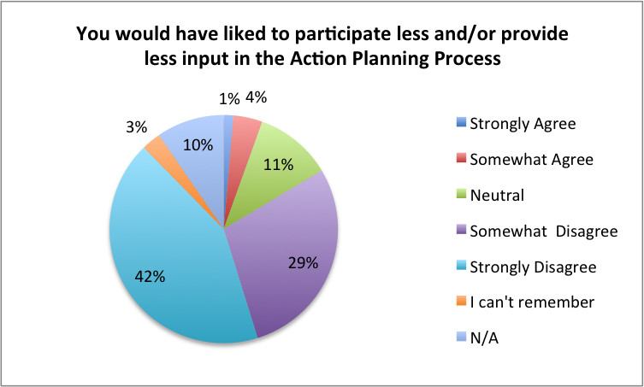

H) Overall, you are satisfied with the level of community engagement used to create the Ten-Year Action Plan.

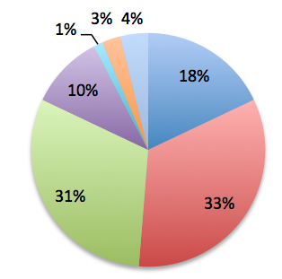

I) Individual Comments:

* I think it is important to provide more background especially to the non-project team participants
* I had a very low level of involvement, which may have been appropriate. I did not have an understanding or even an awareness of the overall process.
* My time was a limiting factor
* I trust the people leading the process and while more engagement is good, decisions must be made to move the process forward
* I did not realize the different levels, and the questions seemed extremely redundant, although basically relevant
* These questions don't get at the tension that I felt as a project team member. I was simultaneously 1) not asked much about the project process, and 2) was asked for an excessive amount of input.

Commentary

* 68% of participants strongly agreed or agreed that they would have liked to provide more input during the process.
* 67% of participants strongly agreed or agreed that they were provided sufficient information to be able to provide meaningful input.
* 52% of participants strongly agreed or agreed that the opportunities for engagement were clearly explained.
* 51% of participants strongly agreed or agreed that they were satisfied with the level of community engagement.

The results of this evaluation suggest that, while this stakeholder engagement was the most comprehensive ever attempted for a Ten-Year Urban Forestry Action Plan, it did not successfully satisfy most of the stakeholders in the way that was hoped. The results suggest that the next Ten-Year Action Plan should select engagement methods that systematically include stakeholders throughout the entire planning process, from beginning to end.

We believe one issue reflected in this evaluation is the fact that the MindMixer method of engagement was stopped after phase one, and this resulted in dissatisfaction from those who had successfully participated in it and would have continued to provide input through that method. When stakeholders are dropped out of a process, for whatever reason, it can be expected to lead to this kind of dissatisfaction and the desire for more inclusion.

In the future, whether stakeholders are engaged through smaller representative groups, focus groups, or through a large national digital engagement outreach, the same people who are engaged in the beginning should continue to be included at every subsequent phase. Additional people can be added as the process progresses, of course, but people should never be dropped off the engagement. In short, in future efforts, it is important to establish a clear method of communication and engagement with the stakeholders and continue that method consistently throughout the process.

***Question 3:***

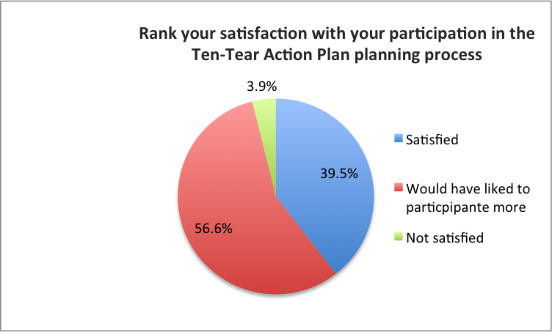

Individual Comments:

* I wish I could have participated more! But you provided countless opportunities and were very engaging; my lack of participation was due to my busy calendar.
* Because of the number of questions asked, it took a lot of time.
* Opportunities to engage federal and state program managers to make this "our plan" and to promote and implement it with confidence were lacking.
* The satisfaction is more about my time limitations.
* Ten-Tear? Are we talking ripped materials or sad events? One more edit would have improved your outreach effort. *[The project team apologizes for the overlooked spelling error in the survey.]*
* As a project team member I wasn't completely satisfied with the process, it wasn't that I wanted to participate more but that I would have liked more efficient staging of the participation.

***Question 4****:*

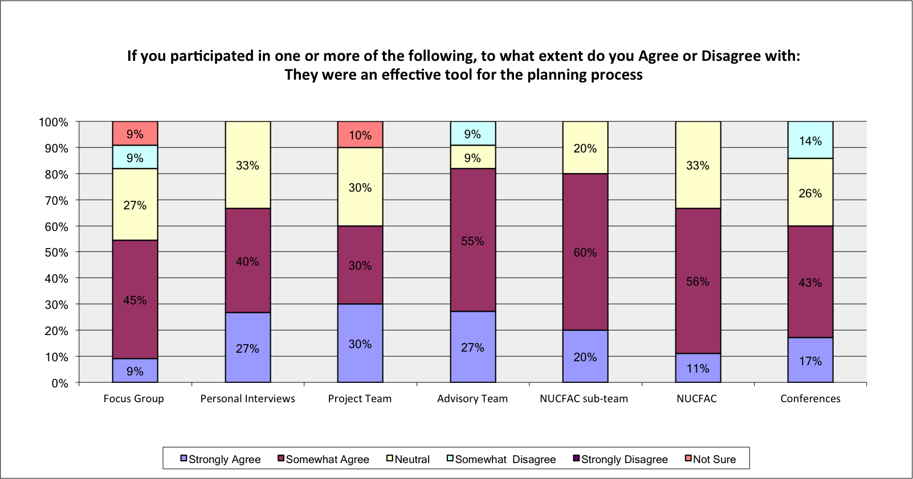

Individual Comments:

* I was at the AAG conference when I first got involved in the group, but was not aware of this action planning process. Would have loved to get more involved.
* I was not informed of any opportunity to participate in any of these forums other than the online MindMixer.
* Mind mixer seemed to have some glitches but concept was good.
* The advisory team should have met at the Partners meeting - the calls were not as effective and were easy to miss. A face-to-face meeting would have been helpful, and deliberate one-on-one connections with each advisory team member. The advisory team seems to serve more as "reviewers" and played less of an advisory role.
* Since I barely remember what this is, I guess it wasn't very effective
* I only knew of the online MindMixer outreach.
* I always felt rushed during participation in the planning activities. Lack of opportunity to work out key product phases resulted in repeated rounds of input and review of the same materials.

**Commentary**

The Project Team schedule proved very difficult, due to the compression of this project from 24 months down to 18 months. It left very little space for a more measured and “adaptive management” planning approach. In the future, we strongly recommend that the full two years be supported.

***Question 5:*** *The use of a digital engagement tool such as MindMixer was a core component of the planning process. Nearly 3,000 people came to the MindMixer site, and 550 people logged their responses and ideas. These numbers reflect an unprecedented interested and engagement in the nation’s urban forestry plan. However, we received feedback from a few people who were not satisfied with this tool, which caused its use to be discontinued as a major avenue for community engagement. If you used MindMixer, or went to site, we want to know more about your experience. Please choose the option that applies to you.*

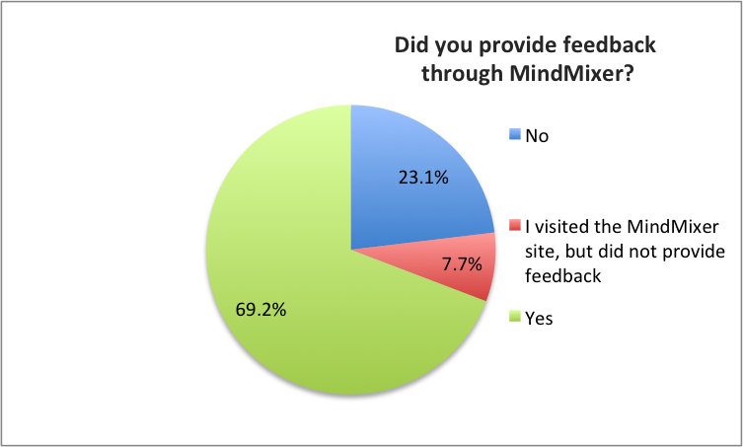

***Question 6:***

1. MindMixer was an easy tool to use

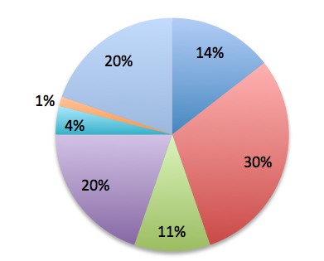

1. MindMixer was an effective tool for online community engagement

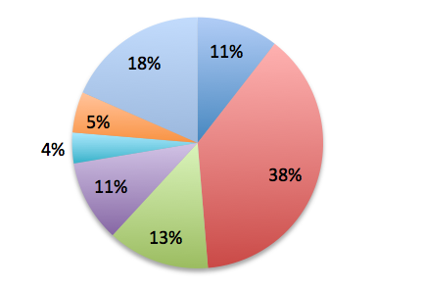

1. The use of MindMixer expanded the outreach of the Action Plan planning process

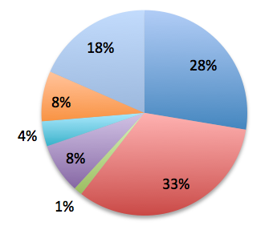

1. In ten years, community engagement tools used for this process should reflect the state of the art.

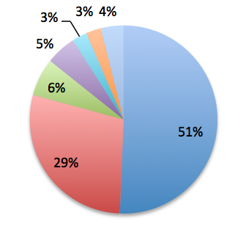

1. In ten years, community engagement tools selected for this process should be easily accessible and easy to use by as many stakeholders as possible.

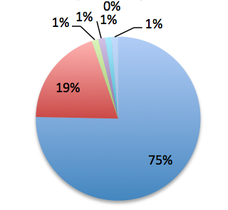

1. In ten years, community engagement tools selected for this process should ensure participation by those who are underserved and have the least technological access.

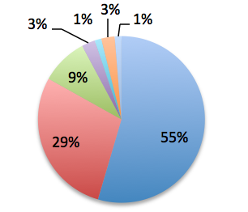

Based on this feedback, it’s clear that MindMixer was a mixed bag. It did expand the outreach of the planning process, but the overall support of participants for MindMixer is lukewarm at best. This reflects our own assessment that MindMixer proved a detriment, overall, if only because its discontinuation left most of the MindMixer participants dissatisfied; it’s as if they were invited to lunch and received only half a serving. Additionally, MindMixer proved a detriment because it was not well-suited for the complex types of feedback that this process sought and needed. This underscores the lesson that the selection of digital engagement is much like selection of the right tree for the right site: you need to select the right engagement tool for the specific needs and goals of the process.

# *Question 7: In ten years, when the next Ten-Year Urban Forestry Action Plan is created, what specific lessons might you suggest for community engagement?*

Project Leadership:

* No specific changes. I thought this was an impressive engagement process using best available systems, and in the future as/if additional systems become available they can be integrated.
* Kudos for all of your outreach during the entire project, including the booth at the Partners meeting and presentations at NUCFAC and the SUFC annual meeting. These were effective in updating critical members of the community and soliciting input. Larger regional meetings might be considered next time, to capture a broader group, since many any of the same people are at these national venues. The booth at the Partner's meeting was nicely done.
* As a member of the project team, and with limited budget and therefore capacity to devote to this process, I could have been more effective in filling my role if I had a better sense of the various players, committees, etc. involved, as well as some access to conversations outside the Project Team.

Outreach:

* Better integration of the disparate stakeholders who impact the urban forest.
* Use of other tools like my Sidewalk could have been useful.
* Assist to meetings in major cities, and have more involvement with universities who have connections with communities.
* Include such stakeholders as the Arbor Day Foundation, Shade Tree Programs and Utility Co. and City Arborists along with Parks & Rec/Street Tree programs and neighborhood associations. My community is a City of Trees member; were these type entities included this time?
* Host live calls. Doing all via email and on-line and conference calls is tough to bring it alive. If there was a need or an appropriate venue, hosting a webinar might help. Also, attending conferences such as SUFC was certainly a good way to connect with target audiences and bring process to life.
* Overall communication should be much better. Please reach out more beyond your core urban forestry contacts.
* High numbers of participants are not an assurance of quality input. The methods of social science research (identifying key informants, sampling, generating summary analytics) can and should be utilized for future outreach. Methods for national level studies (equating to the purpose of engagement) are well developed.
* City or countywide surveys to the public synthesized by municipal managers for input could be a suggestion.
* Host regional community outreach and engagement workshops in collaboration with the corresponding regional nonprofits and urban forestry advocacy groups.
* Greater involvement by the "customers" of urban forestry efforts and what they think, and less involvement of UF practitioners and what they think.
* Use the best tech available in the moment.
* Find partner organizations outside of normal partnerships. They will need to be educated about the program and the history behind it.
* Look for stakeholders that may not seem obvious, such as a trucking firm that uses roads that are tree lined.
* Would like to reach sectors beyond the current actors.
* Open opportunities for in-person meetings/conference calls by region; engage the state forester or forest coordinator, who should be engaging their region.
* Not sure how it worked last time but having each state urban forestry council suggest membership on planning committees; might broaden the base of folks involved.
* Use social media
* With so many opportunities for community engagement, I believe most people choose the topics they are most passionate about and the tools they are comfortable with and confident using. If the passion is powerful enough, some may stretch to an unfamiliar tool. But to collect the most information from the greatest number, a familiar forum with reasonable accommodations for accessibility is best.
* More analysis of social media performance as research background prior to asking for input
* Engaging underserved communities and those without sufficient access to technology can be facilitated by partner organizations, but does not need to drive the whole process. Clearly articulating how various partner groups early and often will use this plan is critical.
* Bring in the forest service futurist team to inform and guide the community engagement process
* I have to wait 10 years before I hear from you again? Perhaps you need to consider a methodology for more continuous engagement.
* First we shouldn't wait 10 years. We should be looking 3 to 4 years out and making any adjustments warranted by new technology and information. The discussion has to get out of the tree advocates and into greater society.
* Broaden inter-connections and activities between academia, extension agencies, municipal government policy makers, natural resource companies, and horticultural activities; particularly in regions that lack formidable professional influences.
* Coordinate with local and/or regional urban forestry conferences or events to engage people that attend. Alternatively, focus on regional ISA membership groups to disseminate surveys.
* Look for ease of input, multiple venues, and an open and transparent process.
* It is good to allow many to have input, but it appears from the draft plan that there was no filter about comments accepted in the plan. Specifically, the idea that only native trees are better is in serious dispute.

*MindMixer:*

* People will participate and support planning process if they believe they have been heard. It also helps to let them know if their input made a difference, even if it didn't. The technology you've used is effective in reaching out to people, but it still doesn't assure participants that their time wasn't wasted.
* Try old-fashioned methods of calling and meetings. Mind mixer is sucky.
* Employ a user-friendly interface for gathering data.
* Be sure the interface is more functional and logically intuitive.
* I thought that MindMixer was a great idea for including more people in the feedback process for creating the Ten-Year Urban Forestry Action Plan. I realize that not every has access to the technological tools necessary to respond to MindMixer, but it was a good first step. There was a lot of information to review, but that's understandable because something as important as a ten-year plan should be fairly comprehensive.
* I would like to see an expanded educational piece so that people contributing online had the option to watch more short PowerPoints or videos explaining some of the key discussion items.
* I was prompted to fill out the MindMixer survey on three related websites.

General Suggestions:

* Make grants available to all sizes of nonprofits and for god's-sake the paperwork needed to apply is simply insane! Figure out a workaround.
* Not sure if this applies, but read about Detroit's "blexting" approach for blighted homes/neighborhoods. To contribute, all they had to do was "blext" the address (blight + text). You don't need a smartphone or Internet connection to use it. Just a thought.
* Take a step back and allow for a "wish list" from the general public. Even here in TX, we have 7 or 8 eco-regions and our forests differ. But our desire for shade or less flood damage is common, regardless.
* Case studies should be included from successful projects.
* Articles in International Society of Arboriculture magazine and Society of Municipal Arborists magazine should be use as reliable sources.
* Utilize the current plan in the next one - there will likely be items that were not implemented or should be recognized as an accomplishment to move into the next 1-year plan as a next phase.

Other:

* Arboricultural services provided by the local electric utility.
* I wish I had something to share.
* Local involvement and community centered.
* Essay contests with significant prizes.

***Question 8:*** *What changes/improvements would you suggest for the next Ten-Year Action Plan planning process?*

Outreach:

* Seek more involvement by utility arborists
* Regional workshops that are facilitated by experts to capture specific needs for local community members within a region.
* More industry engagement - ISA/ASCA/TCIA...
* Open regional forums to the general public to acquire more input and information-needs.
* Don't wait 10 years to talk to stakeholders.
* Broader early outreach to those working in urban forests, prior to process beginning to garner new inputs and stakeholders.
* Wider international participation.
* Work with existing community leadership groups of stakeholders for collaborative submittals on things important to the group; Engage the forest service more in the process. They are where the funding will likely come from. If the plan is kept alive, the next 10-year plan may be an update or realignment. I don't know if the full process is needed. It depends on where we are and how the public is engaged.
* Work harder to get the message out to diverse community leaders that these are priorities for populated areas. Make trees vital as filling potholes, and adding sidewalks.
* Include more GIS/visual infographic tools. People are re-learning to think visually and we need to enable that form of expression and input. Maybe use "sliders" to allow people to ask about more shade or more acreage of forest preferences, or more street trees, or more school campus trees. You may get fragmented replies, but they will reflect the personal experience of your respondents.
* I really appreciate the commitment to community engagement from this round of planning. I hope that this will remain a part of the process for the next plan.
* More personal outreach to industry leaders.

MindMixer:

* Reach out to as many stakeholders as possible, entities such as those I mentioned above. As I indicated before I was unaware of any planning process until I was sent the MindMixer and if I had not taken some time to read and investigate what it was about, I would not have been able to participate in any way. So, I suggest better communication of the process and ways to participate. I don't know why you would abandon MindMixer. I think a lot could be expanded and improved and if more knew what it was about you may have seen much more participation.
* It would be great to make MindMixer a bit more user friendly. I remember that it took a lot of clicks to see details about each goal, and perhaps there's a way to color code or make it easier to navigate between the headings of the goals and their details.
* MindMixer was a great idea but it wasn't easy or intuitive to use - if there are other platforms to explore, test them ahead of time.
* The online tool is the way to go. Too many questions made me feel I was being tested on my previous answers please fewer questions.
* Simpler navigation of website, was a bit complex. This may have been available and I just forgot -- but open up for participants to provide just one or two suggestions or remarks without having to dive into details and provide comments for every element.

General Suggestions:

* We all know what needs to be done. Lets stop talking about it and go do it. What does it take to get the Urban Forest supported financially and in policy and enforcement by local governments?
* Those 10-year plans should be reviewed and revised at least once every two years or more.
* Overall, process was comprehensive and well executed for such a complex task with significant effort to engage as many stakeholders as possible.
* The advisory group should be larger, assuming members engage at different times and levels - would help having some overlap of representative disciplines/sectors. Having the research component so separate for the planning process was confusing and it should be much more integrated.
* I'd have liked to seen a draft before this survey.
* Eradicating the exploitation of poor communities. Promoting and supporting people of color in leadership capacity in their own communities. Promoting the principles of environmental justice.
* Start the process early, before the current plan expires.
* Regular check-in with leadership.
* Slow down the process a little (but you already know this).
* I think the next planning process should clearly state the merits of the 10-Year Plan and why I should participate. Are we just going through the motions of satisfying a legislative requirement or will the final plan make a real difference and actually be used by NUFAC and the US Forest Service? Tell us how the previous or current plan was used. Did NUCFAC/US Forest Service track its accomplishments? If so, then I know that this plan has value and purpose. And if I know that, then I'm more willing to participate in the new plan's process and support its goals, objectives, and recommendations.
* An expanded timeline and slower pace would be an improvement, 18-24 months if possible.
* A clear mission statement with review of previous 10-year progress.
* Invest in tools, processes, and champions that lead to a more focused end product.
* Focus the process on the big picture of urban forests - there needs and issues on a national level and for each state. The current process looses the big picture with too much focus on all the different professional disciplines and entities (re-capture their priorities with out addressing the big picture of what will it take to design and build the best urban forests in every community)
* It's nice to have community engagement, but NUCFAC seems to minimize those of us who work on the frontlines of community forestry every day. How much do you care about what we have to say? Not much, based on the trends we see in where and how dollars are allocated and who is providing input to steer the future in urban forestry.
* A clear-cut agenda and more posting of activities was needed.

Other:

* None!
* I repeat 7, a lesson and suggestion for change. High numbers of participants are not an assurance of quality input. The methods of social science research (identifying key informants, sampling, generating summary analytics) can and should be utilized for future outreach. Methods for national level studies (equating to the purpose of engagement) are well developed.
* Do not know enough about the process to comment
* No suggested changes come to mind
* Hard to say at this juncture
* None
* I wish I had something to share.
* Not sure
* See above.
  + 1. **Assessment of Programs, Activities, Tools and Resources:**

Part of the action planning process required by federal legislation involved the assessment of the status of urban and community forestry programs, activities, tools, and resources. As the team began the assessment process, it quickly learned that no tracking system for progress in these areas was present. The need for establishing a progress tracking system has been recognized by the National Urban and Community Forestry Council, and it is a priority of theirs to institute and use a tracking system, which will make the next assessment in ten years an easier task. In the absence of this tracking

system, the Project Team settled on using two approaches: qualitative and quantitative.

*Qualitative Assessment*:

For qualitative information about progress made in the past ten years, the following steps were taken:

* The Project Team (PT), Advisory Team (AT), Urban and Community Forestry state-level coordinators in all 50 states, NUCFAC board members, and U.S. Forest Service staff (USFS), were all asked to identify documents, websites, articles, and reports that would contribute to a ten-year retrospective assessment.
* More than 60 thought leaders were recommended by the PT, AT, NUCFAC, and USFS. From these, 25 were selected to represent broad national geographic and substantive diversity. During the in-depth interviews, thought leaders were asked to share their perspective and insights about progress made in the last ten years, as well as to highlight specific progress in the realm of programs, activities, tools, and resources.
* The PT, AT, NUCFAC, USFS, and 26 thought leaders were asked to identify key issues that are facing the field of urban and community forestry, as well any global or regional trends that would be influencing the field over the next ten years.
* Graduate students at the Institute for Environmental Negotiation (IEN) conducted an in-depth literature search, and also researched the leads provided by all project advisors. More than 150 urban and community forestry documents were identified as relevant and assembled as a result of this effort, including the 2010 “Vibrant Cities” report, and the 2010 Federal analysis of the 50 state Forest Resource Assessments entitled “Urban and Community Forest Related Content in 2010 Statewide Forest Resource Assessments.” In a second path of research, the team also scanned available resources (documents, websites, tools, etc.),

*Quantitative Assessment:*

* The IEN team continued to assemble more documents referred by members of the PT/ AT/ NUCFAC. The team continued to sort, coding, and analyze these documents in a spreadsheet format. Once the priority Action Plan Goals were finalized in Spring 2015, this spreadsheet was analyzed to determine how often each of Goals 1 to 7 were mentioned or addressed in the urban forestry documents (including reports, websites, etc.). This analysis was done to identify where the last ten years have proven to be strong, and where there are gaps – indicating a need for attention in the next ten years. The results of this analysis are shown in pie charts in this Appendix.
* The USDA Forest Service provided the “Community Accomplishment Reporting System” (CARS) to the IEN team for analysis. CARS is a detailed set of data collected from the Urban Forest Coordinators throughout the nation, and it represents progress made in specific arenas between 2005 to 2012.
* The IEN conducted an analysis of these data, and the graphic results are provided in the Action Plan Appendix, as well as in relevant places throughout Goals 1 to 7.

**Assessment Sources:**

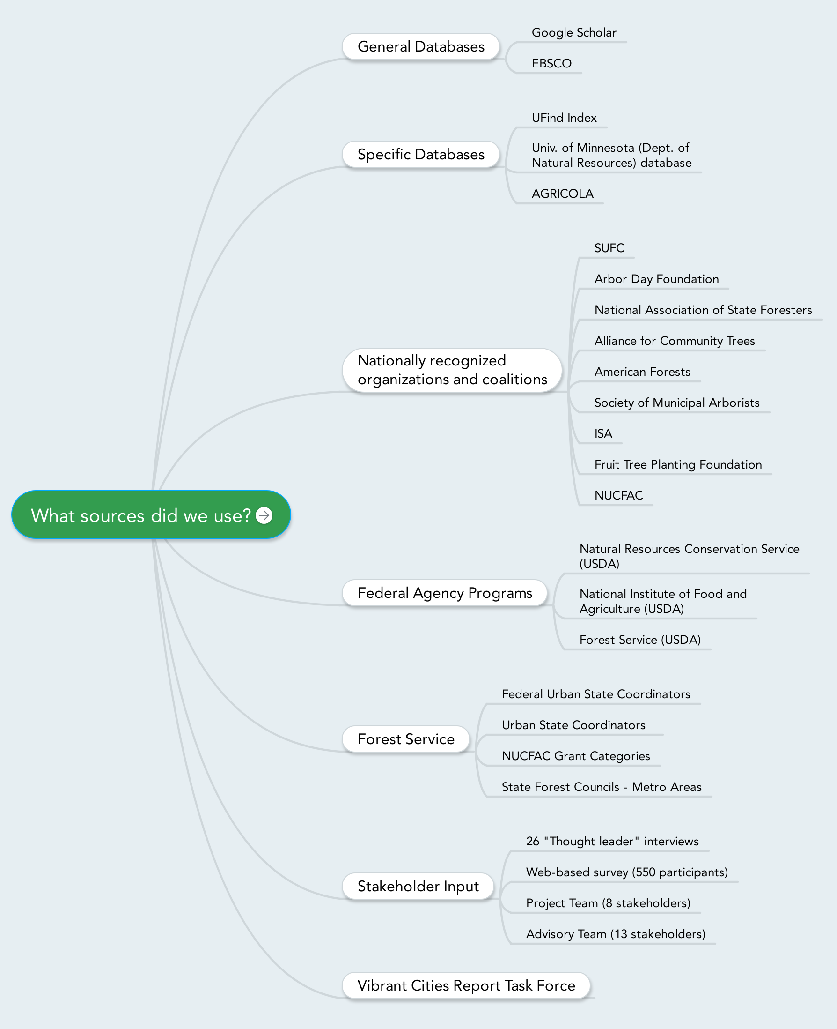

* + 1. **Partner Organizations:** 9 partner organizations where consulted and provided advice, input, and guidance through the process
  1. Sustainable Urban Forest Coalition SUFC
  2. Arbor Day Foundation
  3. National Association of State Foresters
  4. Alliance for Community Trees
  5. American Forests
  6. Society of Municipal Arborists
  7. American Forest Foundation
  8. NUCFAC
  9. University of Washington
  10. University of Maryland
  11. Urban Forests Councils

**Section B: Qualitative Analysis – Lessons Learned**

1. **Project** **and Advisory Team Evaluation Calls:**

* Project Team Evaluation Discussion Summary: (September 9, 2015)

*Meetings:*

* One member said that having monthly calls was very helpful. However, being able meet face to face would also have been a lot more fun and helpful.

*Facilitation Team role:*

* Another member commented that flexibility of this project team has been amazing as well and being able to respond to items and comments was great. Especially considering how much data was gathered in what was practically a one-year process.
* One member expressed that the team has been a lot of fun, and the facilitation from Christine Gyovai and Tanya Denckla Cobb was very helpful.
* The consultants have consolidated the information very well, even though there was so much data and things to filter through. This participant didn’t know how that could have been any smoother or tighter to prevent constant back and forth.

*Methodology used:*

* One member commented that there should be a separation between the input phase and product development phase, so that there is no simultaneous work (there was a need to constantly work on product development, editorial reviews and comments at the same time).
* One facilitator mentioned the Team could have engaged the Council earlier on so they had ownership and could provide feedback to the research and funding sections.
* Another member mentioned it was also challenging working with the volunteer group, because new people came on board.
* The team agrees that the information gathering phase will be instrumental in the next ten years that can be sifted down and have a three or four day retreat to hash out a draft plan.
* Strategic Advisory Team Evaluation Discussion Summary: (September 9, 2015)

*Methodology used:*

* One member thought at first the process was too fast, but now feels it was a perfect amount of time. This member also really appreciated the level of public engagement and use of technology. However, he thinks there is missing a sense of accomplishments of the previous the ten-year period. Thus, the USFS needs to evaluate what has been accomplished in this ten-year plan for the next action plan. A suggestion is to have a section of what is currently going on, the current accomplishments of the UCF today.
* Another member reiterated the need for reflection of what the last Ten-Year Action Plan accomplished, highlighting methods that truly worked so we can show people that this ten-year plan truly performed.
* Another member said the public engagement was great but also overwhelming, difficult to go through all of the ideas that flowed in. But it was good (and necessary) that a lot of people took ownership of the plan. The last Ten-Year Action Plan faltered because no one knew whose plan it belonged to whereas now there are already several people interested in helping implement the plan, which is exciting!

*Suggestions for next 10 years:*

* On moving forward for the next Ten-Year Action Plan, the main concern is “how to we evaluate this plan?” There is a need to measure how communities have changed and how this have impacted or changed society or larger systems, including the world of urban forestry.
* Another member emphasized the council needs to keep the lines of communication open, giving people a sense of ownership over the plan. It is important for the community to know what NUCFAC is and what their plan is and know that they can help implement that plan. In response, a member mentioned a template for recommendations and accomplishments created for the annual report. This is a way NUCFAC can track progress with benchmarks and milestones to report to the Secretary of Agriculture what has been accomplished.

**Reflections from the Facilitation Team (IEN Team and Dialogue + Design)**

* The process was too compressed; the team felt routinely too rushed in the turn around times, and not enough time to give feedback, so the facilitation team ended up pushing people and people felt pushed. It really needed to be a full two-year project.
* Digital engagement will be the wave of the future, and there will always be new ways to manage the amounts of information coming in, but there should be a back-up for those who don’t have access to the digital technology. In the next ten-year plan, the planning process shouldn’t use a “too new” technology; it should be well-tested and should be the right tool for the type of engagement desired.
* It was very difficult to assess the last ten years because there was little to no data tracking urban forestry progress.
* There is value to face-to-face focus groups and strategic planning retreats – that is something we would strongly recommend be done in the next ten years.
* The project leadership needs clear guidance and leadership from NUCFAC. The project was difficult because of conflicting and sometimes opposing views of Council members who sought to influence the plan by individually approaching the facilitation team. If the Council experiences conflicted goals and perspectives about what should happen –a common phenomenon for boards composed of people who do not have the opportunity to build relationships or work together frequently –it may be helpful to have its ten-year planning meetings formally facilitated using a consensus-building techniques.
* There is a need to find more effective and deliberate ways of reaching out to underserved communities in the next Ten-Year Action Plan.
* We strongly encourage a different structure to the planning process in the next ten-year plan. We recommend that the Council be engaged at the outset of the process, to provide input into the planning process, help think through and design the community engagement process, and to begin articulating the high-level aspirations and goals for the Ten-Year Action Plan. All of this would increase the Council’s ownership in Action Plan, and would increase the effectiveness of the planning process.
* We encourage the use of webinars and virtual engagement methods to personalize the engagement for broader groups of stakeholders.
* We also encourage the use of face-to-face engagement methods of smaller focus groups of experts on specific topics; this would personalize the engagement and also help ensure that the planning process engagement is informed and focused.
* Lastly, we encourage that the process end with a final webinar (or its equivalent in ten years) for all participants to learn about the process, the input that was received, how input was used or not used, and to allow for final participant questions and suggestions. This would be an important addition to the process that would reflect internationally accepted best practices.